Computer Language Coding Concepts

Command Calls in a Command Call in a Diagram
Command calls in a command call have been conceptually explained in the article Command Calls in a Command Call.

This article only illustrates how command calls in a command call look in a diagram.

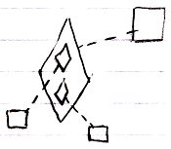

The bigger diamond is a command call, because it is tied to its definition, the larger square, with a dashed line, a class line. The smaller diamonds inside the larger diamonds are command calls inside a command call. The smaller diamonds also point out their definitions, the smaller squares, with a dashed line, a class line.

The creation behavior of command calls in a command call will not be further explained with diagrams in this article. Refer to the article Creation Behavior of Sub-Commands in a Diagram for an illustration of how the creation behavior of command calls looks in a diagram.

See also: Command Calls in a Command Call,
Creation Behavior of Sub-Commands in a Diagram

Author & Copyright: Jan-Joost van Zon Date: August 9, 2008 – August 12, 2008 Location: Oosterhout, The Netherlands Status: Finished

